BRANTHAM PARISH COUNCIL

INVITATION TO TENDER

Design and Build of a Concrete Skate Park

At Lower Playing Field, Temple Pattle, Brantham, CO11 1RW

Contract Reference | BPC/2026/SKP/001
Issued by | Brantham Parish Council
Address | Thornfield Cottage, Windmill Road, Bradfield, CO11 2QW
Email contact | clerk@branthamparishcouncil.gov.uk
Issue Date | 29 July 2026
Tender Return Deadline | 28 August 2026
Return Method | By email to info@branthamparishcouncil.gov.uk

This document is confidential and issued to invited tenderers only. It must not be disclosed to any third party without the prior written consent of Brantham Parish Council.

Brantham Parish Council will publish this Invitation to Tender and associated procurement documents on its website to ensure transparency and equal access to information for all potential tenderers.

Any clarifications issued during the tender period will also be published on the Council’s website.

This document must be completed and returned in the published format. Failure to comply with this instruction may result in your submission being rejected.

Section 1 — Introduction and Background
Brantham Parish Council (the Council) invites tenders for the design and build of a new concrete skate park at the Lower Playing Field in Brantham, Suffolk (What3Words location: ///indulgent.freshen.rooster).
Image 1. Skate Park proposed location:
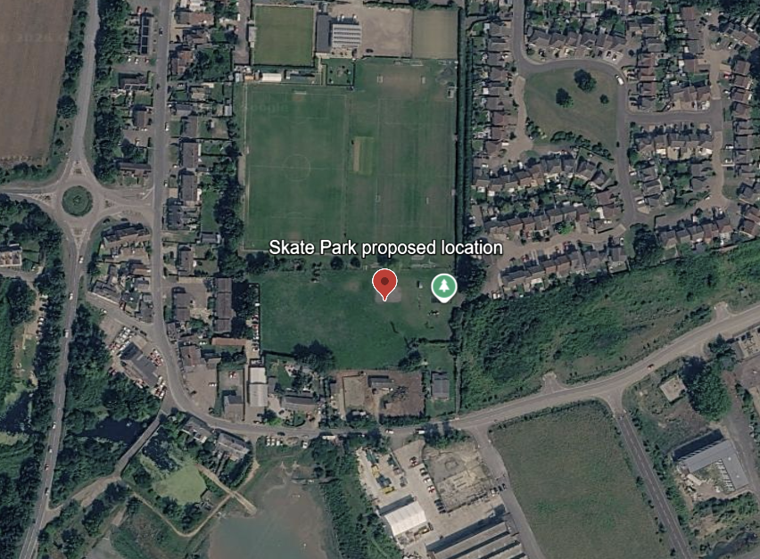
Image 2. Current Playing field
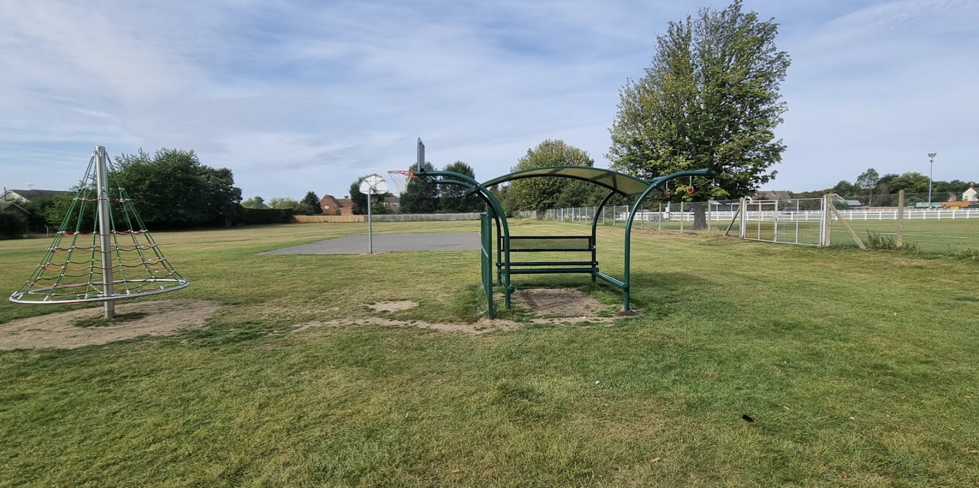
This Invitation to Tender (ITT) sets out the requirements of the project and the information tenderers must provide in order to be considered for the contract.
Brantham Parish Council is the local authority representing the parish of Brantham in Suffolk. The Council is responsible for providing and maintaining a range of local services, facilities, and community assets for the benefit of residents, visitors, and local organisations. Through effective stewardship of public resources, the Council seeks to enhance the quality of life within the parish and support the long-term wellbeing of the community.
As part of its Brantham 2034 Strategic Vision, Brantham Parish Council is committed to enhancing recreational opportunities and promoting healthier, more active lifestyles for residents of all ages.
As part of this commitment, the Council is seeking to appoint a suitably qualified and experienced contractor to design and construct a new skate park within the parish. The Council wishes to create a space that supports active lifestyles, encourages social interaction and provides opportunities for people to develop new skills and build confidence. The facility should appeal to a broad range of users, from young children taking their first steps on balance bikes and scooters through to teenagers and adults using skateboards, BMX bikes and inline skates. Recognising that skateboarding is now an Olympic sport, the design should provide a high-quality facility that supports skill development at every level, inspiring participation, progression and excellence while remaining inclusive, accessible and welcoming to beginners.
The facility is intended to serve not only residents of Brantham but also those from surrounding villages and the wider local area. The Council wishes to create a destination that is recognised as a positive addition to the village and a place where people can come together in a safe and supportive environment.
Project Requirements
The successful contractor will be required to provide a complete design-and-build solution, including design development, construction, installation, testing, commissioning and handover. Tenderers should demonstrate how they will work collaboratively with the Council to develop a final design that reflects the aspirations of the local community while delivering a safe, durable and engaging facility.
The Council's vision is for a skate park that functions as a multi-use recreational space throughout the day. During daytime hours it should be suitable for younger children using scooters and balance bikes under parental supervision, while after school, evenings and weekends it should provide a vibrant social space for older children, teenagers and other users. The design should encourage physical activity, social interaction and the development of friendships across different age groups.
The Council is particularly keen to ensure that the skate park feels welcoming rather than intimidating. The design should provide opportunities for beginners and less experienced users to participate confidently while also incorporating features that allow users to develop their skills over time. The facility should therefore cater for a range of abilities without being dominated by highly advanced features that may discourage participation by younger or less experienced users.
The skate park should support a variety of wheeled sports. The Council is interested in designs that combine different styles of riding and provide a range of experiences for users. Consideration should be given to incorporating distinct areas within the facility to allow different user groups to coexist safely. This may include separate zones for beginners and more experienced users and, where appropriate, the inclusion of a bowl area.
The Council has identified a jump box as a particularly desirable feature and would welcome proposals that incorporate this element within a well-balanced and coherent overall design. Equally important is the creation of clear circulation routes that allow users to move safely and naturally throughout the facility.
Community Space and Inclusivity
The Council views the skate park as more than a sports facility. It should be designed as a community space where families, spectators and participants feel comfortable spending time. The design should encourage informal social interaction and support activities such as coaching sessions, skateboarding lessons, community events and skate jams.
Seating will therefore form an important part of the overall scheme. Seating areas should be positioned to provide good visibility across the facility, allowing parents and carers to supervise younger users while also creating opportunities for social interaction and community engagement. The overall layout should create a safe, friendly and welcoming atmosphere that integrates positively with the surrounding environment.
Quality, Safety and Durability
The completed facility must be designed and constructed to the highest standards of quality and safety. All works must comply with relevant legislation, industry standards and best practice guidance applicable to skate park design and construction.
The Council is seeking a robust, low-maintenance facility capable of withstanding intensive public use over many years. Tenderers should clearly explain the materials, construction methods and design approaches proposed to maximise durability, minimise maintenance requirements and ensure long-term value for money.
Project Delivery and Handover
Tenderers should provide details of their proposed approach to project management, including communication arrangements, programme management, quality assurance procedures and health and safety management. A dedicated project manager should be appointed as the principal point of contact throughout the project.
Upon completion, the successful contractor will be required to provide all relevant certification, warranties, maintenance information and as-built documentation. Tenderers should also outline any aftercare, inspection or maintenance support services available following completion.
The site is located on a Recreational Field and includes a children's play area and open grassed area used for football and other sporting activity, making it an ideal hub for outdoor recreation and community activity.
Section 2 — Key Information
2.1 Procurement Timetable
Invitation to Tender Issued | 29 July 2026
Site visits (optional) | By appointment
Deadline for clarification questions | 14 August 2026 (12 noon)
Clarification responses issued | 17 August 2026
Tender submission deadline | 28 August 2026 (12 noon)
Shortlisting | Week commencing 31 August 2026
Tender presentations by shortlisted tenderers (if required) | Week commencing 07 September 2026
Evaluation of tenders | September 2026
Anticipated contract award | Late September 2026
Anticipated contract commencement | October 2026
2.2 Contract details
Contracting Authority | Brantham Parish Council
Contract Title | Design and Build of a Concrete Skate Park — Brantham
Contract Reference | BPC/2026/SKP/001
Contract Type | Works — Design and Build
Estimated Contract Value | £200,000 to £220,000 (excluding VAT)
CPV Code | 45212200-8 – Construction work for sports facilities
Procurement Type | Open Tender
Tender Deadline | 28 August 2026 — submissions by email only
Tender Presentations | Week commencing 07 September 2026
Contact | clerk@branthamparishcouncil.gov.uk

2.3 Evaluation Methodology
Tenders will be evaluated using the Most Advantageous Tender (MAT) approach. The Council will assess each compliant tender against the quality and price criteria set out below. The contract will be awarded to the Tenderer achieving the highest overall weighted score.
The Council reserves the right to seek clarification of any aspect of a tender and, where stated within this Invitation to Tender, may invite shortlisted Tenderers to attend a presentation. Any presentation will form part of the published evaluation criteria and will not introduce additional evaluation criteria.
The evaluation criteria and weightings are as follows:
- Price - 30%
- Design Quality and user experience - 20%
- Technical Specification and durability - 15%
- Experience and track record - 10%
- Project delivery - 10%
- H&S / Risk Management - 5%
- Community and Environmental Value - 5%
- Warranty / Aftercare - 5%

The following requirements will be assessed on a pass/fail basis prior to evaluation;
- submission of a complete tender
- satisfactory financial standing
- appropriate insurance cover
- acceptance of the Conditions of Tender
- adequate Health & Safety policy.
Section 3 — Site Information and Scope of Works
3.1 Site visit and site information
Tenderers are strongly encouraged to visit the site before submitting a tender in order to familiarise themselves with the location, access arrangements, existing facilities and any constraints that may affect the design or construction of the works.
The site is located at:
Lower Playing Field, Temple Pattle, Brantham, Suffolk, CO11 1RW
The site may be viewed from publicly accessible areas at any reasonable time. Should a Tenderer wish to arrange an accompanied site visit, this may be arranged by contacting the Clerk at clerk@branthamparishcouncil.gov.uk.
Tenderers shall be deemed to have satisfied themselves as to all matters affecting their tender, including site conditions, access, neighbouring uses and any other factors that may influence the execution of the works.
Tenderers should note that the Lower Playing Field will remain in public use throughout the construction period. The site is adjacent to a children's play area, sports pitches, and pedestrian routes. Tenderers should describe how they propose to maintain public safety and minimise disruption during the works.
3.2 Scope of works
The successful contractor will be required to provide a full design and build service. The scope includes, but is not limited to:
- Consultation with the Council and, where required, the local community to develop a design that reflects the needs of all user groups
- Full architectural and engineering design of the concrete skate park
- Obtaining any statutory approvals, Building Control approvals (where applicable), utility consents and any other permissions required for the construction of the works, in liaison with the Council
- Site preparation, demolition and clearance of existing surface (if applicable)
- Earthworks, sub-base and foundation construction
- Drainage design and installation
- Construction of all concrete skate park features including bowls, street sections, transition ramps and flat ground areas
- Peripheral works including paths, edging, kerbing and boundary treatments
- Signage, seating and any associated street furniture
- Landscaping and reinstatement of surrounding areas
- Full testing, commissioning and formal handover to the Council
- Provision of as-built drawings, maintenance manuals and warranty documentation
The successful Contractor shall provide:
- all relevant completion certificates and test certificates;
- as-built drawings and maintenance manuals;
- manufacturer's warranties for all installed products and equipment;
- a minimum 12-month defects liability period, during which any defects attributable to design, materials or workmanship shall be rectified at no additional cost to the Council; and
- details of any structural warranty offered for the skate park.

The design must cater for a wide range of ages and abilities, from beginner children through to experienced adult skateboarders, and must comply fully with all relevant British Standards, safety guidance (including RoSPA and Fields in Trust guidance) and all other applicable statutory requirements.
Section 4 — Conditions of Tender
4.1 Tender Submission
Tenders must be submitted electronically by email to info@branthamparishcouncil.gov.uk no later than 12 noon on Friday 28 August 2026.
The subject line of the email should read:
Tender Submission – BPC/2026/SKP/001 – Design and Build of a Concrete Skate Park
The completed ITT and all supporting documents should be submitted in PDF format wherever possible. Where supporting documents are provided in their original format (for example, Excel pricing schedules or programme files), these should also be included.
It is the Tenderer's responsibility to ensure that the complete tender is received by the deadline. Tenders received after the deadline will not be considered.
The Council will acknowledge receipt of all tenders received before the submission deadline. If a Tenderer has not received an acknowledgement within one working day of submission, it is the Tenderer's responsibility to contact the Council before the submission deadline to ensure that the tender has been received.
4.2. Modification or Withdrawal of Tenders
A Tenderer may withdraw or replace its tender at any time before the submission deadline by notifying the Council in writing. No amendments will be accepted after the submission deadline.
4.3. Tender Presentations
Following evaluation of the written tenders, the Council may invite one or more Tenderers to attend a presentation and interview.
The purpose of the presentation is to enable Tenderers to explain their proposals, demonstrate their understanding of the project and respond to questions from the evaluation panel.
Tenderers invited to present will be notified in writing and provided with details of the date, time and venue. The Council anticipates that presentations will last approximately 45–60 minutes, including questions.
The presentation may cover, but is not limited to:
- the proposed design approach;
- project methodology and programme;
- construction techniques;
- health and safety arrangements;
- management of the project team;
- budget management and value engineering;
- aftercare and maintenance.
Where presentations form part of the evaluation process, they will be assessed against the published evaluation criteria. Tenderers will not be assessed on any criteria that have not previously been published within this Invitation to Tender.
The Council reserves the right not to invite Tenderers to present where it considers this unnecessary.
4.4 General Conditions
- Tenders must remain valid for a minimum of 90 days from the submission deadline.
- The Council reserves the right to accept or reject any tender, and is not bound to accept the lowest price.
- Tenderers must not canvass any member or officer of the Council in connection with this tender.
- The Council will not reimburse tenderers for any costs incurred in preparing or submitting a tender.
- Submission of a tender shall be deemed acceptance of these conditions.
4.5 Clarifications
Any queries regarding this ITT must be submitted in writing by email to clerk@branthamparishcouncil.gov.uk by 12 noon on 14 August 2026. All clarification questions and answers will be shared with all tenderers to ensure fairness and transparency.
No verbal advice or clarification provided by any Member or Officer of the Council shall form part of this procurement unless confirmed in writing to all Tenderers.
4.6 Sub-Contracting Arrangements
Where the Supplier proposes to use one or more sub-contractors to deliver some or all of the contract requirements, a separate Appendix should be used to provide details of the proposed bidding model that includes members of the supply chain, the percentage of work being delivered by each sub-contractor and the key contract deliverables each sub-contractor will be responsible for.
The Council recognises that arrangements in relation to sub-contracting may be subject to future change and may not be finalised until a later date. However, Suppliers should be aware that where information provided to the Council indicates that sub-contractors are to play a significant role in delivering key contract requirements, any changes to those sub-contracting arrangements may affect the ability of the Supplier to proceed with the procurement process or to provide the supplies and/or services required. Suppliers should therefore notify the authority immediately of any change in the proposed sub-contractor arrangements. The Council reserves the right to deselect the Supplier prior to any award of contract, based on an assessment of the updated information.

4.7 Verification of Information Provided
Whilst reserving the right to request information at any time throughout the procurement process, the Council may enable the Supplier to self-certify that there are no mandatory/ discretionary grounds for excluding their organisation.

4.8 Contract Award
Following completion of the evaluation process, the Council intends to award the contract to the Tenderer submitting the Most Advantageous Tender, having regard to the published evaluation criteria. The Council reserves the right not to award the contract or to discontinue the procurement at any time.
Section 5 — Company Information and Experience
Please complete all fields below. Where a question requires a written response, please use the answer box provided. Attach additional sheets if necessary, clearly labelled with the question number.
5.1 Organisation Details

Full Legal Name of Organisation
Trading Name (if different)
Registered Address
Company Registration Number
VAT Registration Number
Organisation Type | e.g. Limited Company / Sole Trader / Partnership / Other
Date Established
Number of Employees
Principal Contact for this Tender
Contact Telephone
Contact Email

Bidding Model | Please place X in the relevant box
- Bidding as a Prime Contractor and will deliver 100% of the key contract deliverables yourself

- Bidding as a Prime Contractor and will use third parties to deliver some of the services

If yes, please provide details of your proposed bidding model that includes members of the supply chain, the percentage of work being delivered by each sub-contractor and the key contract deliverables each sub-contractor will be responsible for.
- Bidding as Prime Contractor but will operate as a Managing Agent and will use third parties to deliver all of the services

If yes, please provide details of your proposed bidding model that includes members of the supply chain, the percentage of work being delivered by each sub-contractor and the key contract deliverables each sub-contractor will be responsible for.

Supplier contact details for enquiries about this Questionnaire
Name
Postal address
Country
Phone
Mobile
E-mail
5.2 Relevant Experience

Please describe your organisation's experience in the design and construction of concrete skate parks. Include details of comparable projects completed in the last five years, including scale, value and any particular design challenges overcome.

What makes your organisation particularly well suited to deliver this project for Brantham Parish Council? Please highlight any specialist skills, equipment or in-house expertise relevant to this contract.
Have you previously worked with local councils, parish councils or other public sector bodies? If so, please provide brief details.
Section 6 — Financial Standing and Insurance
6.1 Financial Information
Please confirm the following. Supporting documentation (e.g. most recent set of accounts) must be attached with your submission.

Annual Turnover (most recent financial year) | £
Annual Turnover (previous financial year) | £
Are you aware of any circumstances that could affect your financial stability? | Yes ☐ No ☐

If you answered Yes above, please provide details:

Non-payment of taxes
Has it been established by a judicial or administrative decision having final and binding effect in accordance with the legal provisions of any part of the United Kingdom or the legal provisions of the country in which your organisation is established (if outside the UK), that your organisation is in breach of obligations related to the payment of tax or social security contributions?

If you have answered Yes to this question, please use a separate Appendix to provide further details. Please also use this Appendix to confirm whether you have paid, or have entered into a binding arrangement with a view to paying, including, where applicable, any accrued interest and/or fines?

6.2 Insurance
Please confirm current insurance cover held. Certificates must be provided with your tender submission.

Insurance Type | Level of Cover Held | Expiry Date
Public Liability (minimum £5,000,000 required) | £
Employers Liability (minimum £10,000,000 required) | £
Professional Indemnity | £
Contractors All Risks | £

Section 7 — Technical Methodology and Approach

This section asks you to set out how you would approach the design and delivery of this project. Your responses will be assessed as part of the quality evaluation.
7.1 Design Approach
Please describe your proposed approach to the design of the skate park, including how you would ensure the facility meets the needs of all age groups and skill levels. How would you engage with the Council and community during the design process?

7.2 Concept Design Submission
As part of your tender submission, please provide sufficient design information to demonstrate your proposed approach to the skate park. This should include, as a minimum:
- a scaled concept layout showing the overall arrangement of the facility;
- a 3D visualisation or perspective images illustrating the proposed design;
- indicative dimensions and the principal skate features;
- an explanation of how the design caters for users of different ages, abilities and wheeled sports;
- details of proposed seating, spectator areas and any ancillary features; and
- a brief design statement explaining the design philosophy and how it responds to the Council's objectives.
The concept design is intended to demonstrate the Tenderer's understanding of the project and design capability. The Council reserves the right to work collaboratively with the successful Tenderer to refine and develop the final design following contract award.
7.3 Construction Methodology
Please outline your proposed construction methodology, including key stages, sequencing and any phasing that may be required. How would you manage the construction process to minimise disruption to the surrounding area, including the adjacent play area, community centre and wellbeing park?

7.4 Programme
Please provide a proposed programme for the delivery of this contract, from design commencement through to practical completion and handover. Indicate key milestones and any factors that could affect the programme.
7.5 Quality and Innovation
What quality assurance processes will you put in place to ensure the skate park is built to the highest standard? Are there any innovative approaches, materials or features you would propose to enhance the facility?

Section 8 — Health and Safety
8.1 Accreditations and Certifications
Please confirm which of the following your organisation currently holds. Copies of certificates must be submitted with your tender.

Item | Yes | No
CHAS (Contractors Health and Safety Assessment Scheme) accreditation | ☐ | ☐
Constructionline or equivalent membership | ☐ | ☐
ISO 45001 (or OHSAS 18001) Health and Safety Management System | ☐ | ☐
ISO 9001 Quality Management System | ☐ | ☐
ISO 14001 Environmental Management System | ☐ | ☐
Membership of the Freestyle Skateparks Association (FSPA) or equivalent body | ☐ | ☐
Current DBS / safeguarding policy (given proximity to children's play area) | ☐ | ☐

8.2 Health and Safety Policy
Please provide a summary of your organisation's Health and Safety policy and how it would be applied on this project. How would you manage the safety of the public, including children, given the site's proximity to other community facilities?

8.3 Incidents and Enforcement
Please disclose any Health and Safety enforcement notices, improvement notices, prohibition notices or prosecutions received by your organisation in the last three years. If none, please state 'None'.

Section 9 — Pricing Schedule
Please complete the pricing schedule below. All prices must be in pounds sterling (£) and exclusive of VAT unless stated. Where quantities are not yet defined (e.g. where design has not been finalised), please provide a rate that will be used to calculate the final cost.

Note: The pricing schedule below is indicative. Tenderers may add or adjust line items as appropriate to reflect their proposed methodology, provided all elements of the scope of works are accounted for. Any assumptions must be clearly stated.

Item No. | Description | Unit | Qty | Rate (£) | Total (£)
1 | Preliminary works, site set-up and temporary works | Sum | 1
2 | Demolition / clearance of existing surface (if applicable) | Sum | 1
3 | Earthworks and site levelling | m²
4 | Sub-base and foundation works | m²
5 | Drainage design and installation | Sum | 1
6 | Concrete skate park construction — bowl / street / transition features | m²
7 | Peripheral concrete works (paths, edging, kerbing) | m
8 | Safety surfacing / impact zones (where applicable) | m²
9 | Fencing / boundary treatments | m
10 | Signage and information boards | No.
11 | Seating / spectator provision (if included) | No.
12 | Lighting (if included) | No.
13 | Landscaping and reinstatement | Sum | 1
14 | Testing, commissioning and handover | Sum | 1
15 | Allowance for contingency (% of total) | %
 | TOTAL EXCLUDING VAT
 | VAT @ 20%
 | TOTAL INCLUDING VAT

Please set out any assumptions, exclusions or qualifications that underpin your pricing. Identify any items that carry particular commercial risk and explain how these have been priced.

Please confirm your payment terms and your proposed interim payment schedule (e.g. stage payments linked to programme milestones).

Please describe the warranty and aftercare arrangements included within your tender, including: defects liability period, structural warranty, response times for remedial works, availability of inspection and maintenance services.

Budget Management
The Applicant shall describe its proposed approach to managing the budget, working with the Parish Council to manage any potential cost overruns and reporting cost information to the Council.
The Council has allocated a budget of around £200,000 to £220,000 (excluding VAT) for this project.
Tenderers should describe how they will work collaboratively with the Council to deliver the highest quality facility within the available budget. Where a tender exceeds the available budget, Tenderers should clearly identify any options for value engineering or alternative design solutions that could reduce costs while maintaining the Council's objectives.
Council’s minimum requirements: Please note that the Council is looking for a Contractor that is willing to work with the Council to manage the costs of the project within the allocated budget.
Response:

Section 10 — References
Please provide details of three organisations for whom you have completed skate park or comparable works contracts within the last five years. The Council reserves the right to contact these references as part of the evaluation process. Please ensure referees are aware they may be contacted.
Reference 1
Organisation / Client Name
Contact Name
Contact Telephone
Contact Email
Project Description
Contract Value (approx.)
Date Completed
Your Role

Reference 2
Organisation / Client Name
Contact Name
Contact Telephone
Contact Email
Project Description
Contract Value (approx.)
Date Completed
Your Role

Reference 3
Organisation / Client Name
Contact Name
Contact Telephone
Contact Email
Project Description
Contract Value (approx.)
Date Completed
Your Role

Section 11 — Declarations and Submission
Tenderers must complete and sign the Form of Tender (Appendix A) and return it with their submission.
The declarations contained within the Form of Tender will be treated as part of the Tender submission.

Appendix A – Form of Tender
BRANTHAM PARISH COUNCIL
Project: Design and Build of a Concrete Skate Park at Lower Playing Field, Temple Pattle, Brantham, CO11 1RW
Contract Reference: BPC/2026/SKP/001
- Tenderers Details
Organisation Name
Registered Address
Company Registration Number
VAT Registration Number
Contact Name
Position
Telephone
Email

2. Tender Offer
Having examined the Invitation to Tender and all accompanying documents, we hereby offer to undertake the Design and Build of the Brantham Parish Council Skate Park in accordance with the requirements of the Invitation to Tender.
This Tender constitutes an irrevocable offer capable of acceptance by Brantham Parish Council during the Tender Validity Period.
We confirm that our Tender Sum is:
Tender Price (excluding VAT)

£________________________

VAT

£________________________

Total Tender Price (including VAT)

£________________________

3. Tender Validity
We confirm that this tender shall remain open for acceptance for a period of 90 days from the Tender Return Deadline.
4. Contract Period
We confirm that, subject to contract award, we are able to commence the works within the timescales set out in our tender submission.
Proposed contract duration:

________________________ weeks
Estimated completion date:
5. Declarations
We certify that:
Tick
Here:
We have read and understood the Invitation to Tender
We have examined the project requirements and are satisfied that we have sufficient information to submit this tender
We accept the Conditions of Tender contained within the Invitation to Tender.
The tender price submitted includes all costs necessary to complete the works described, except where specifically identified within our tender.
We confirm that the information supplied within our tender submission is true and accurate.
We have disclosed any actual or potential conflicts of interest.
We understand that Brantham Parish Council is not bound to accept the lowest, or any, tender received.
We agree to enter into a formal contract if our tender is accepted.

6. Conflicts of Interest
Please declare any actual or potential conflicts of interest that may affect this procurement. If none, please state “None”

7. Confidential Information
Please identify any information contained within your tender which you consider commercially confidential and explain why.

8. Authorised Signature
I certify that I am authorised to sign this tender on behalf of the organisation named above.
Name:

Position:

Organisation:

Signature:

Date:

9. Checklist
Please ensure the following have been submitted:
Item | Yes | No
Completed Form of Tender | ☐ | ☐
Completed Invitation to Tender | ☐ | ☐
Pricing Schedule | ☐ | ☐
References | ☐ | ☐
Insurance Certificates | ☐ | ☐
Financial Information | ☐ | ☐
Health & Safety Documentation | ☐ | ☐
Supporting Design Information | ☐ | ☐
Any additional appendices referenced within the tender | ☐ | ☐
10. Submission
Completed tenders must be received no later than 12.00 noon on Friday 28 August 2026 by email to info@branthamparishcouncil.gov.uk
Email Subject: Tender Submission – BPC/2026/SKP/001

Thank you for your interest in this opportunity.

Completed tenders should be submitted by email to info@branthamparishcouncil.gov.uk by 12 noon on 28 August 2026.

Brantham Parish Council | Thornfield Cottage, Windmill Road, Bradfield, CO11 2QW | 01206 645111

